Monthly Performance Report – September 2025
Kestrel Ridge Wind Farm (75.6 MW)
David Chen · 09 October 2025 · KR-OPS-RPT-2025-09

1. Summary
Kestrel Ridge generated 15.2 GWh in September 2025, 2.0 % above the P50 budget of 14.9 GWh. Time-based availability was strong at 97.8 % (contract target 97.0 %). Mean hub-height wind speed of 7.6 m/s was close to the long-term mean (7.6 m/s). Compared with September 2024 (13.5 GWh), output was up 1.7 GWh.
Annual service campaign completed on 26 September (all 18 turbines). Blade inspections by drone found Category 2 leading edge erosion on 9 blades, scheduled for repair in 2026/2027.

2. Production and key figures
KPI | September 2025 | Budget / target | YTD 2025 | YTD budget
Net generation (GWh) | 15.2 | 14.9 | 142.5 | 148.5
Time-based availability | 97.8 % | 97.0 % | 97.4 % | 97.0 %
Capacity factor | 27.9 % | 27.4 % | 28.8 % | –
Mean wind speed at hub height (m/s) | 7.6 | 7.6 | – | –
Source: Kestrel Ridge SCADA, revenue meter at 132 kV point of connection. Budget = P50 (2024 post-construction yield assessment).
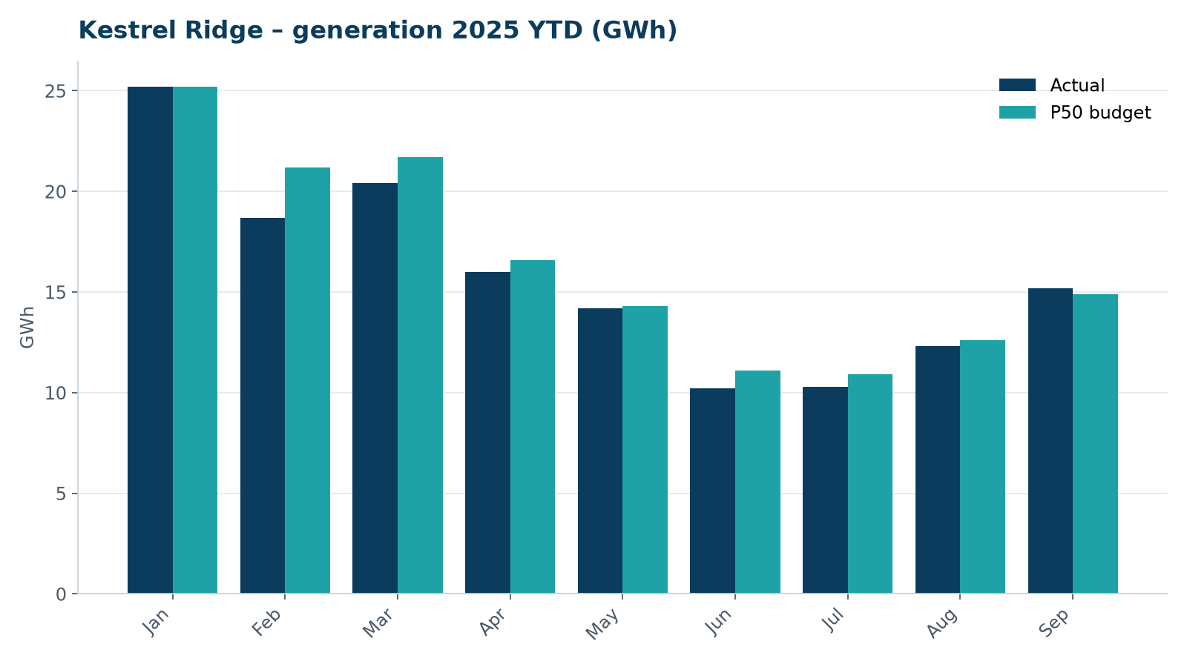
Monthly generation vs. P50 budget, 2025 year to date

3. Availability and downtime
Total turbine downtime attributable to the contractor amounted to 65 turbine-hours for the top events listed below. No grid or force majeure exclusions were claimed this month.
Turbine | Event | Downtime (h)
T-17 | pitch motor encoder fault on blade B | 20
T-12 | hydraulic oil leak at rotor brake caliper | 15
T-11 | converter fault – IGBT module replaced | 15
T-04 | yaw brake pad wear – pads replaced | 10
T-18 | service lift fault – lift locked out, turbine stopped for rescue cover | 5
Top downtime events of the month (SCADA event log, reviewed with Highline Wind Services).

4. Maintenance
- Annual service: 2 turbines completed this month.
- 15 corrective work orders closed, 4 still open at month end.
- Substation monthly inspection completed; no abnormalities on the 33/132 kV transformer.

5. Health, safety and environment
Indicator | Month
Hours worked on site (Highline + Weyland) | 3,603
Lost time injuries | 0
First aid cases | 0
Near misses reported | 0
Safety observations | 12
Environmental incidents | 0

No environmental incidents. Bird carcass searches were carried out on schedule (fortnightly, all turbines).

6. Outlook
The P50 budget for next month assumes normal seasonal wind; no planned outages beyond routine maintenance.
Prepared by Sara Lindgren (Performance Analyst); reviewed by Ben Okoye (Site Manager) and David Chen (Asset Operations Manager).

